**Assignment-6**

**Write a PHP program to keep track of the number of visitors visiting the web page and to display this count of visitors, with proper headings.**

***Prog6.php***

<?php

$user = "YourName";

?>

<!DOCTYPE html>

<html>

<head>

    <title> program 6 </title>

</head>

<body>

    <h2><?php echo $user; ?>,Welcome to Sample PHP Script </h2>

    <?php

    print "<h3> REFRESH PAGE </h3>";

    $name = "counter.txt";

    $file = fopen($name, "r");

    $hits = fscanf($file, "%d");

    fclose($file);

    $hits[0]++;

    $file = fopen($name, "w");

    fprintf($file, "%d", $hits[0]);

    fclose($file);

    print "Total number of views: " . $hits[0];

    ?>

</body>

</html>

***Counter.txt***

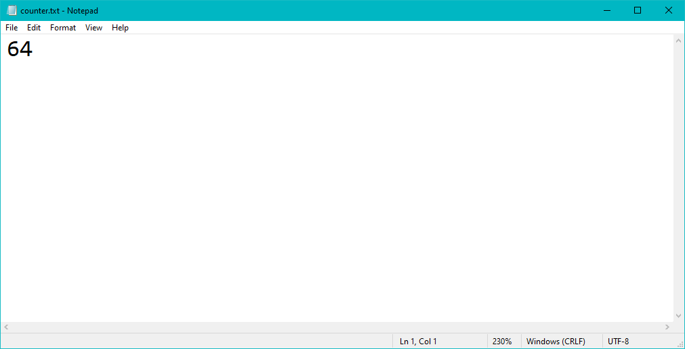

**Output:**

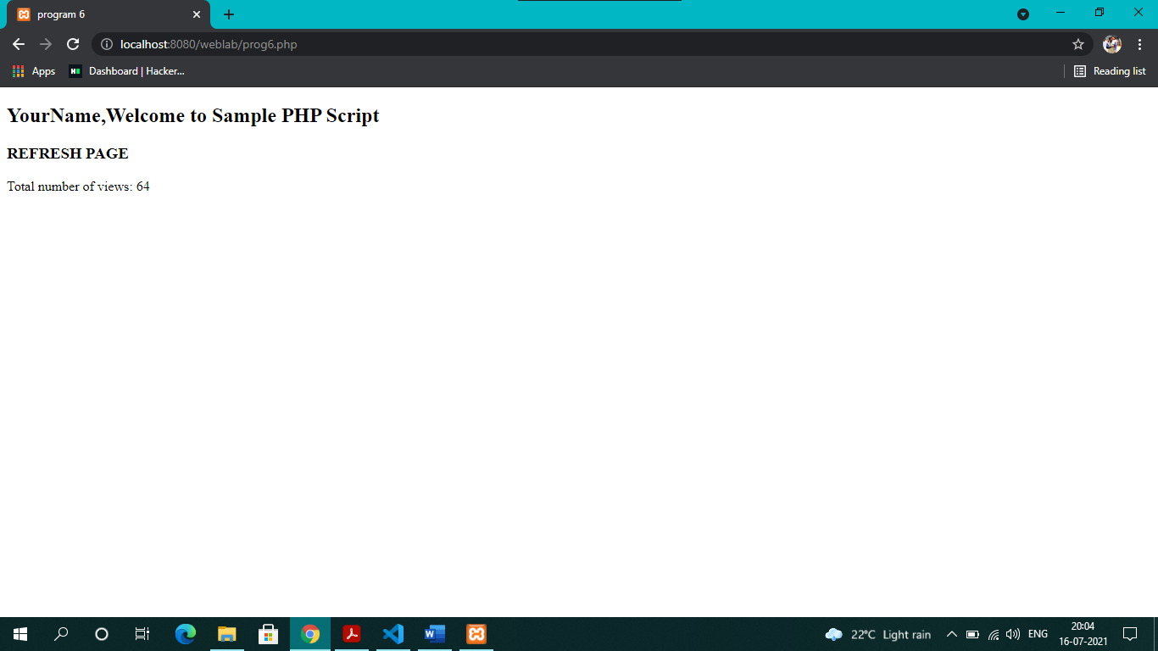

***Prog6_a.php***

<?php

$user = "Naveen Dasapalli";

?>

<!DOCTYPE html>

<html>

<head>

    <link rel="stylesheet" href="prog6_a.css">

    <link rel="preconnect" href="https://fonts.googleapis.com">

    <link rel="preconnect" href="https://fonts.gstatic.com" crossorigin>

    <link href="https://fonts.googleapis.com/css2?family=Dancing+Script&family=Tourney:ital,wght@1,900&display=swap" rel="stylesheet">

    <title> program 6_a </title>

</head>

<body>

    <h2><?php echo $user; ?>,Welcome to Sample PHP Script </h2>

    <?php

    print "<h3> REFRESH PAGE </h3>";

    $name = "counter_a.txt";

    $file = fopen($name, "r");

    $hits = fscanf($file, "%d");

    fclose($file);

    $hits[0]++;

    $file = fopen($name, "w");

    fprintf($file, "%d", $hits[0]);

    fclose($file);

    print "Total number of views: " . $hits[0];

    ?>

    <div class="profile">

        <img src="naveen.png" alt="profile picture"></img>

        <div class="container">

            <h4><b><?php echo $user; ?></b></h4>

            <p>6th Sem Computer Science Department</p>

        </div>

    </div>

</body>

</html>

***Prog6_a.css***

h2{

    background-color: goldenrod;

    font-family: 'Dancing Script', cursive;

    text-align: center;

}

h3{

    top: 0;

    font-family: 'Tourney', cursive;

}

body{

    background-color: rgb(27, 141, 235);

}

.profile {

    padding-top: 10px;

    background-color: #edd766;

    position: relative;

    display: block;

    margin-left: auto;

    margin-right: auto;

    box-shadow: 0 4px 8px 0 rgba(0,0,0,0.2);

    border-radius: 20px;

    transition: 0.3s;

    width: 30%;

}

.profile:hover {

    box-shadow: 0 8px 16px 0 rgba(0,0,0,0.2);

  }

img{

    border-radius: 100%;

    display: block;

    margin-left: auto;

    margin-right: auto;

    border: 3px solid black;

    box-shadow: 0 4px 8px 0 rgba(0,0,0,0.2);

}

.container {

    font-family: 'Dancing Script', cursive;

    text-align: center;

    padding: 2px 16px;

}

***Counter_a.txt***

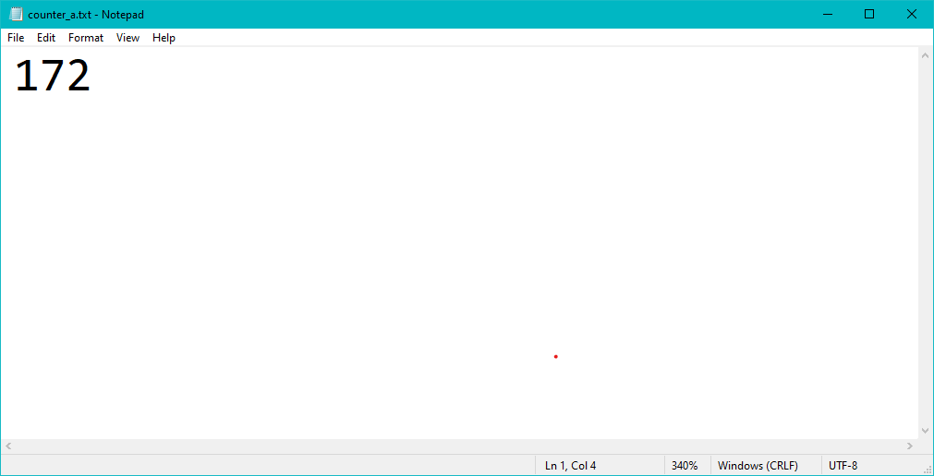

**Output:**

